CHAPTER 11

TEACHING NOTES

Much of the material in this chapter is usually postponed, or not covered at all, in an introductory course. However, as Chapter 10 indicates, the set of time series applications that satisfy all of the classical linear model assumptions might be very small. In my experience, spurious time series regressions are the hallmark of many student projects that use time series data. Therefore, students need to be alerted to the dangers of using highly persistent processes in time series regression equations. (Spurious regression problem and the notion of cointegration are covered in detail in Chapter 18.)

It is fairly easy to heuristically describe the difference between a weakly dependent process and an integrated process. Using the MA(1) and the stable AR(1) examples is usually sufficient.

When the data are weakly dependent and the explanatory variables are contemporaneously exogenous, OLS is consistent. This result has many applications, including the stable AR(1) regression model. When we add the appropriate homoskedasticity and no serial correlation assumptions, the usual test statistics are asymptotically valid.

The random walk process is a good example of a unit root (highly persistent) process. In a one-semester course, the issue comes down to whether or not to first difference the data before specifying the linear model. While unit root tests are covered in Chapter 18, just computing the first-order autocorrelation is often sufficient, perhaps after detrending. The examples in Section 11.3 illustrate how different first-difference results can be from estimating equations in levels.

Section 11.4 is novel in an introductory text, and simply points out that, if a model is dynamically complete in a well-defined sense, it should not have serial correlation. Therefore, we need not worry about serial correlation when, say, we test the efficient market hypothesis. Section 11.5 further investigates the homoskedasticity assumption, and, in a time series context, emphasizes that what is contained in the explanatory variables determines what kind of heteroskedasticity is ruled out by the usual OLS inference. These two sections could be skipped without loss of continuity.

SOLUTIONS TO PROBLEMS

11.1 Because of covariance stationarity, 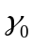 = Var(x_{t}) does not depend on t, so sd(x_{t+h}) = 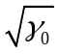 for any h ≥ 0. By definition, Corr(x_{t},x_{t+h}) = Cov(x_{t},x_{t+h})/[sd(x_{t})sd(x_{t+h})] = 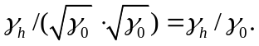

11.2 (i) E(x_{t}) = E(e_{t}) – (1/2)E(e_{t-1}) + (1/2)E(e_{t-2}) = 0 for t = 1,2, Also, because the e_{t} are independent, they are uncorrelated and so Var(x_{t}) = Var(e_{t}) + (1/4)Var(e_{t-1}) + (1/4)Var(e_{t-2}) = 1 + (1/4) + (1/4) = 3/2 because Var (e_{t}) = 1 for all t.

(ii) Because x_{t} has zero mean, Cov(x_{t},x_{t+1}) = E(x_{t}x_{t+1}) = E[(e_{t} – (1/2)e_{t-1} + (1/2)e_{t-2})(e_{t+1} – (1/2)e_{t} + (1/2)e_{t-1})] = E(e_{t}e_{t+1}) – (1/2)E(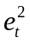) + (1/2)E(e_{t}e_{t-1}) – (1/2)E(e_{t-1}e_{t+1}) + (1/4(E(e_{t-1}e_{t}) – (1/4)E(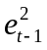) + (1/2)E(e_{t-2}e_{t+1}) – (1/4)E(e_{t-2}e_{t}) +(1/4)E(e_{t-2}e_{t-1}) = – (1/2)E() – (1/4)E() =
–(1/2) – (1/4) = –3/4; the third to last equality follows because the e_{t} are pairwise uncorrelated and E() = 1 for all t. Using Problem 11.1 and the variance calculation from part (i), Corr(x_{t}x_{t+1}) = – (3/4)/(3/2) = –1/2.
Computing Cov(x_{t},x_{t+2}) is even easier because only one of the nine terms has expectation different from zero: (1/2)E() = ½. Therefore, Corr(x_{t},x_{t+2}) = (1/2)/(3/2) = 1/3.

(iii) Corr(x_{t},x_{t+h}) = 0 for h >2 because, for h > 2, x_{t+h} depends at most on e_{t+j} for j > 0, while x_{t} depends on e_{t+j}, j ≤ 0.

(iv) Yes, because terms more than two periods apart are actually uncorrelated, and so it is obvious that Corr(x_{t},x_{t+h}) → 0 as h → ∞.

11.3 (i) E(y_{t}) = E(z + e_{t}) = E(z) + E(e_{t}) = 0. Var(y_{t}) = Var(z + e_{t}) = Var(z) + Var(e_{t}) + 2Cov(z,e_{t}) = 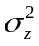 + 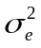 + 20 = + . Neither of these depends on t.

(ii) We assume h > 0; when h = 0 we obtain Var(y_{t}). Then Cov(y_{t},y_{t+h}) = E(y_{t}y_{t+h}) = E[(z + e_{t})(z + e_{t+h})] = E(z²) + E(ze_{t+h}) + E(e_{t}z) + E(e_{t}e_{t+h}) = E(z²) = because {e_{t}} is an uncorrelated sequence (it is an independent sequence and z is uncorrelated with e_{t} for all t. From part (i) we know that E(y_{t}) and Var(y_{t}) do not depend on t and we have shown that Cov(y_{t},y_{t+h}) depends on neither t nor h. Therefore, {y_{t}} is covariance stationary.

(iii) From Problem 11.1 and parts (i) and (ii), Corr(y_{t},y_{t+h}) = Cov(y_{t},y_{t+h})/Var(y_{t}) = /( + ) > 0.

(iv) No. The correlation between y_{t} and y_{t+h} is the same positive value obtained in part (iii) now matter how large is h. In other words, no matter how far apart y_{t} and y_{t+h} are, their correlation is always the same. Of course, the persistent correlation across time is due to the presence of the time-constant variable, z.

11.4 Assuming y₀ = 0 is a special case of assuming y₀ nonrandom, and so we can obtain the variances from (11.21): Var(y_{t}) = t and Var(y_{t+h}) = (t + h), h > 0. Because E(y_{t}) = 0 for all t (since E(y₀) = 0), Cov(y_{t},y_{t+h}) = E(y_{t}y_{t+h}) and, for h > 0,

E(y_{t}y_{t+h}) = E[(e_{t} + e_{t-1} + e₁)(e_{t+h} + e_{t+h-1} + + e₁)]
= E() + E() + + E(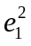) = t,

where we have used the fact that {e_{t}} is a pairwise uncorrelated sequence. Therefore, Corr(y_{t},y_{t+h}) = Cov(y_{t},y_{t+h})/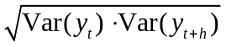 = t/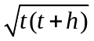 = 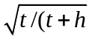.

11.5 (i) The following graph gives the estimated lag distribution:

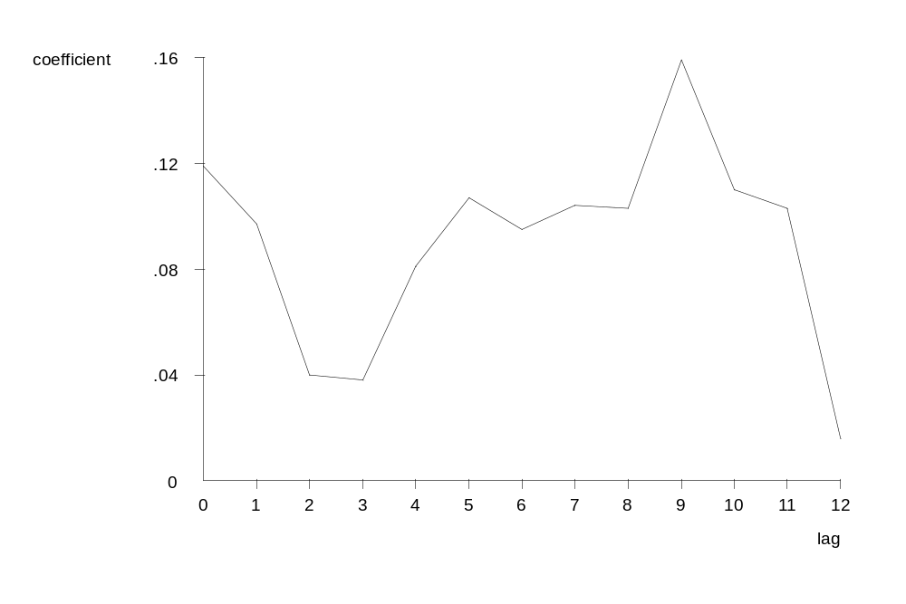
By some margin, the largest effect is at the ninth lag, which says that a temporary increase in wage inflation has its largest effect on price inflation nine months later. The smallest effect is at the twelfth lag, which hopefully indicates (but does not guarantee) that we have accounted for enough lags of gwage in the FLD model.

(ii) Lags two, three, and twelve have t statistics less than two. The other lags are statistically significant at the 5% level against a two-sided alternative. (Assuming either that the CLM assumptions hold for exact tests or Assumptions TS.1′ through TS.5′ hold for asymptotic tests.)

(iii) The estimated LRP is just the sum of the lag coefficients from zero through twelve: 1.172. While this is greater than one, it is not much greater, and the difference from unity could be due to sampling error.

(iv) The model underlying and the estimated equation can be written with intercept α₀ and lag coefficients δ₀, δ₁, , δ₁₂. Denote the LRP by θ₀ = δ₀ + δ₁ + + δ₁₂. Now, we can write δ₀ = θ₀ − δ₁ − δ₂ − − δ₁₂. If we plug this into the FDL model we obtain (with y_{t} = gprice_{t} and z_{t} = gwage_{t})

y_{t} = α₀ + (θ₀ − δ₁ − δ₂ − − δ₁₂)z_{t} + δ₁z_{t-1} + δ₂z_{t-2} + + δ₁₂z_{t-12} + u_{t}
= α₀ + θ₀z_{t} + δ₁(z_{t-1} – z_{t}) + δ₂(z_{t-2} – z_{t}) + + δ₁₂(z_{t-12} – z_{t}) + u_{t}.

Therefore, we regress y_{t} on z_{t}, (z_{t-1} – z_{t}), (z_{t-2} – z_{t}), , (z_{t-12} – z_{t}) and obtain the coefficient and standard error on z_{t} as the estimated LRP and its standard error.

(v) We would add lags 13 through 18 of gwage_{t} to the equation, which leaves 273 – 6 = 267 observations. Now, we are estimating 20 parameters, so the df in the unrestricted model is df_{ur} = 267. Let 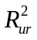 be the R-squared from this regression. To obtain the restricted R-squared, 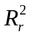, we need to reestimate the model reported in the problem but with the same 267 observations used to estimate the unrestricted model. Then F = [(−)/(1 − )](247/6). We would find the critical value from the F_{6,247} distribution.

[Instructor’s Note: As a computer exercise, you might have the students test whether all 13 lag coefficients in the population model are equal. The restricted regression is gprice on (gwage + gwage₋₁ + gwage₋₂ + gwage₋₁₂), and the R-squared form of the F test, with 12 and 259 df, can be used.]

11.6 (i) The t statistic for H₀: β₁ = 1 is t = (1.104 – 1)/.039 2.67. Although we must rely on asymptotic results, we might as well use df = 120 in Table G.2. So the 1% critical value against a two-sided alternative is about 2.62, and so we reject H₀: β₁ = 1 against H₁: β₁ ≠ 1 at the 1% level. It is hard to know whether the estimate is practically different from one without comparing investment strategies based on the theory (β₁ = 1) and the estimate (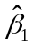= 1.104). But the estimate is 10% higher than the theoretical value.

(ii) The t statistic for the null in part (i) is now (1.053 – 1)/.039 1.36, so H₀: β₁ = 1 is no longer rejected against a two-sided alternative unless we are using more than a 10% significance level. But the lagged spread is very significant (contrary to what the expectations hypothesis predicts): t = .480/.109 4.40. Based on the estimated equation, when the lagged spread is positive, the predicted holding yield on six-month T-bills is above the yield on three-month T-bills (even if we impose β₁ = 1), and so we should invest in six-month T-bills.

(iii) This suggests unit root behavior for {hy3_{t}}, which generally invalidates the usual t-testing procedure.

(iv) We would include three quarterly dummy variables, say Q2_{t}, Q3_{t}, and Q4_{t}, and do an F test for joint significance of these variables. (The F distribution would have 3 and 117 df.)

11.7 (i) We plug the first equation into the second to get

y_{t} – y_{t-1} = λ( + 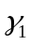x_{t} + e_{t} – y_{t-1}) + a_{t},

and, rearranging,

y_{t} = λ + (1 − λ)y_{t-1} + λx_{t} + a_{t} + λe_{t},
≡ β₀ + β₁y_{t-1} + β₂ x_{t} + u_{t},

where β₀ ≡ λ, β₁ ≡ (1 − λ), β₂ ≡ λ, and u_{t} ≡ a_{t} + λe_{t}.

(ii) An OLS regression of y_{t} on y_{t-1} and x_{t} produces consistent, asymptotically normal estimators of the β_{j}. Under E(e_{t}|x_{t},y_{t-1},x_{t-1}, ) = E(a_{t}|x_{t},y_{t-1},x_{t-1}, ) = 0 it follows that E(u_{t}|x_{t},y_{t-1},x_{t-1}, ) = 0, which means that the model is dynamically complete [see equation (11.37)]. Therefore, the errors are serially uncorrelated. If the homoskedasticity assumption Var(u_{t}|x_{t},y_{t-1}) = σ² holds, then the usual standard errors, t statistics and F statistics are asymptotically valid.

(iii) Because β₁ = (1 − λ), if = .7 then = .3. Further, 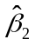= 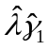, or 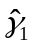= /= .2/.3 ≈ .67.

SOLUTIONS TO COMPUTER EXERCISES

C11.1 (i) The first order autocorrelation for log(invpc) is about .639. If we first detrend log(invpc) by regressing on a linear time trend, 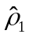 .485. Especially after detrending there is little evidence of a unit root in log(invpc). For log(price), the first order autocorrelation is about .949, which is very high. After detrending, the first order autocorrelation drops to .822, but this is still pretty large. We cannot confidently rule out a unit root in log(price).

(ii) The estimated equation is

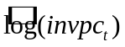 = −.853 + 3.88 ∆log(price_{t}) + .0080 t
(.040) (0.96) (.0016)
n = 41, R² = .501.

The coefficient on Δlog(price_{t}) implies that a one percentage point increase in the growth in price leads to a 3.88 percent increase in housing investment above its trend. [If Δlog(price_{t}) = .01 then Δ = .0388; we multiply both by 100 to convert the proportionate changes to percentage changes.]

(iii) If we first linearly detrend log(invpc_{t}) before regressing it on Δlog(price_{t}) and the time trend, then R² = .303, which is substantially lower than that when we do not detrend. Thus, ∆log(price_{t}) explains only about 30% of the variation in log(invpc_{t}) about its trend.

(iv) The estimated equation is

Δ = .006 + 1.57 Δlog(price_{t}) + .00004t
(.048) (1.14) (.00190)
n = 41, R² = .048.

The coefficient on Δlog(price_{t}) has fallen substantially and is no longer significant at the 5% level against a positive one-sided alternative. The R-squared is much smaller; Δlog(price_{t}) explains very little variation in Δlog(invpc_{t}). Because differencing eliminates linear time trends, it is not surprising that the estimate on the trend is very small and very statistically insignificant.

C11.2 (i) The estimated equation is

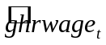 = –.010 + .728 goutphr_{t} + .458 goutphr_{t-1}
(.005) (.167) (.166)
n = 39, R² = .493, 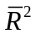 = .465.

The t statistic on the lag is about 2.76, so the lag is very significant.

(ii) We follow the hint and write the LRP as θ = β₁ + β₂, and then plug β₁ = θ – β₂ into the original model:

ghrwage_{t} = β₀ + θ goutphr_{t} + β₂(goutphr_{t-1} – goutphr_{t}) + u_{t}.

Therefore, we regress ghrwage_{t} onto goutphr_{t}, and (goutphr_{t-1} – goutphr_{t}) and obtain the standard error for . Doing this regression gives 1.186 [as we can compute directly from part (i)] and se() = .203. The t statistic for testing H₀: θ = 1 is (1.186 – 1)/.203 .916, which is not significant at the usual significance levels (not even 20% against a two-sided alternative).

(iii) When goutphr_{t-2} is added to the regression from part (i), and we use the 38 observations now available for the regression, 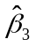 .065 with a t statistic of about .41. Therefore, goutphr_{t-2} need not be in the model.

C11.3 (i) The estimated equation is

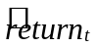 = .226 + .049 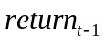 − .0097 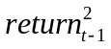
(.087) (.039) (.0070)
n = 689, R² = .0063.

(ii) The null hypothesis is H₀: β₁ = β₂ = 0. Only if both parameters are zero does E(return_{t}|return_{t-1}) not depend on return_{t-1}. The F statistic is about 2.16 with p-value .116. Therefore, we cannot reject H₀ at the 10% level.

(iii) When we put return_{t-1}return_{t-2} in place of the null can still be stated as in part (ii): no past values of return, or any functions of them, should help us predict return_{t}. The R-squared is about .0052 and F 1.80 with p-value .166. Here, we do not reject H₀ at even the 15% level.

(iv) Predicting return_{t} based on past returns does not appear promising. Even though the F statistic from part (ii) is almost significant at the 10% level, we have many observations. We cannot even explain 1% of the variation in return_{t}.

C11.4 (i) The estimated equation in first differences is

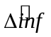 = –.078 – .842 Δunem
(.348) (.314)
n = 48, R² = .135, = .116.

The coefficient on Δunem has the sign that implies an inflation-unemployment tradeoff, and the coefficient is quite large in magnitude. The t statistic on Δunem is about –2.68, which is very significant. In fact, the estimated coefficient is not statistically different from –1: (-.842 + 1)/.314 .5, which would imply a one-for-one tradeoff.

(ii) Based on the R-squareds (or adjusted R-squareds), the model from part (i) explains Δinf better than (11.19): the model with Δunem as the explanatory variable explains about three percentage points more of the variation in Δinf.

C11.5 (i) The estimated equation is

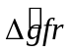 = −1.27 − .035 Δpe − .013 Δpe₋₁ − .111 Δpe₋₂ + .0079 t
(1.05) (.027) (.028) (.027) (.0242)
n = 69, R² = .234, = .186.

The time trend coefficient is very insignificant, so it is not needed in the equation.

(iii) The estimated equation is

= −.650 − .075 Δpe − .051 Δpe₋₁ + .088 Δpe₋₂ + 4.84 ww2 - 1.68 pill
(.582) (.032) (.033) (.028) (2.83) (1.00)
n = 69, R² = .296, = .240.

The F statistic for joint significance is F = 2.82 with p-value .067. So ww2 and pill are not jointly significant at the 5% level, but they are at the 10% level.

(iii) By regressing Δgfr on Δpe, (Δpe₋₁ − Δpe). (Δpe₋₂ − Δpe), ww2, and pill, we obtain the LRP and its standard error as the coefficient on Δpe: −.075, se = .032. So the estimated LRP is now negative and significant, which is very different from the equation in levels, (10.19) (the estimated LRP was .101 with a t statistic of about 3.37). This is a good example of how differencing variables before including them in a regression can lead to very different conclusions than a regression in levels.

[Instructor’s Note: A variation on this exercise is to start with the model in levels and then difference all of the independent variables, including the dummy variables ww2 and pill.]

C11.6 (i) The estimated accelerator model is

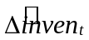 = 2.59 + .152 ΔGDP_{t}
(3.64) (.023)
n = 36, R² = .554.

Both inven and GDP are measured in billions of dollars, so a one billion dollar change in GDP changes inventory investment by $152 million. is very statistically significant, with t 6.61.

(ii) When we add r3_{t}, we obtain

= 3.00 + .159 ΔGDP_{t} − .895 r3_{t}
(3.69) (.025) (1.101)
n = 36, R² = .562.

The sign of is negative, as predicted by economic theory, and it seems practically large: a one percentage point increase in r3_{t} reduces inventories by almost $1 billion. However, is not statistically different from zero. (Its t statistic is less than one in absolute value.)
If Δr3_{t} is used instead, the coefficient becomes about −.470, se = 1.540. So this is even less significant than when r3_{t} is in the equation. But, without more data, we cannot conclude that interest rates have a ceteris paribus effect on inventory investment.

C11.7 (i) If E(gc_{t}|I_{t-1}) = E(gc_{t}) – that is, E(gc_{t}|I_{t-1}) = does not depend on gc_{t-1}, then β₁ = 0 in gc_{t} = β₀ + β₁gc_{t-1} + u_{t}. So the null hypothesis is H₀: β₁ = 0 and the alternative is H₁: β₁ ≠ 0. Estimating the simple regression using the data in CONSUMP.RAW gives

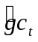 = .011 + .446 gc_{t-1}
(.004) (.156)
n = 35, R² = .199.

The t statistic for is about 2.86, and so we strongly reject the PIH. The coefficient on gc_{t-1} is also practically large, showing significant autocorrelation in consumption growth.

(ii) When gy_{t-1} and i3_{t-1} are added to the regression, the R-squared becomes about .288. The F statistic for joint significance of gy_{t-1} and i3_{t-1}, obtained using the Stata “test” command, is 1.95, with p-value .16. Therefore, gy_{t-1} and i3_{t-1} are not jointly significant at even the 15% level.

C11.8 (i) The estimated AR(1) model is

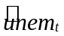 = 1.49 + .742 unem_{t-1}
(0.52) (.089)
n = 55, R² = .566, 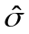 = .999.

In 2003 the unemployment rate was 6.0, so the predicted unemployment rate for 2004 is 1.49 + .742(6) 5.94. From the 2005 Economic Report of the President (Table B−42), the U.S. civilian unemployment rate was 5.5. Therefore, the equation overpredicts the 2004 unemployment rate by almost half a percentage point.

(ii) When we add inf_{t-1} to the equation we get

= 1.30 + .649 unem_{t-1} + .183 inf_{t-1}
(0.44) (.078) (.039)
n = 55, R² = .696, = .843.

Lagged inflation is very statistically significant, with a t statistic of about 4.7.

(iii) To use the equation from part (ii) to predict unemployment in 2004, we also need the inflation rate for 2003. This is given in PHILLIPS.RAW as 2.3. Therefore, the prediction of unem in 2003 is 1.30 + .649(6) + .183(2.3) 5.61. While still too large, it is pretty close to the actual rate of 5.5 percent, and it is certainly better than the predication from part (i).

(iv) We use the model from part (iii) because inf_{t-1} is very significant. To use the 95% prediction interval from Section 6.4, we assume that unem_{t} has a conditional normal distribution. As shown in equation (6.36), we need the standard error of the predicted value as well as the standard error of the regressions. The latter is given in part (ii), = .843. To obtain the standard error of the predicted value, se(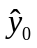) in the notation of Chapter 6, we need to find the standard error of 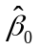 + (6.0) + (2.3). We use the method described in Section 6.4: we run the regression unem_{t} on (unem_{t-1} – 6.0) and (inf_{t-1} – 2.3), and obtain the intercept and standard error from this regression. We know the intercept must be (approximately) 5.61 from part (iii). Its standard error is about .136. Therefore, from equation (6.36),

se() = [(.136)² + (.843)²]^{1/2} .854.

Although the OLS estimators are only approximately normally distributed in the presence of a lagged dependent variable, we use the 97.5th percentile from the normal distribution, 1.96, in constructing the confidence interval. Therefore, the 95% prediction interval for 2004 unemployment is 5.61 ± 1.96(.854), or about 3.94 to 7.28. The actual unemployment rate for 2004, 5.5, is comfortably within this interval. (If we forget to include in obtaining the standard error of the future value, the CI would be about 5.34 to 5.59, which includes 5.5. But this would be an incorrect prediction interval as it ignores the unobservables that affect unem in 2004.)

C11.9 (i) The first order autocorrelation for prcfat is .709, which is high but not necessarily a cause for concern. For unem, 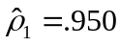, which is cause for concern in using unem as an explanatory variable in a regression.

(ii) If we use the first differences of prcfat and unem, but leave all other variables in their original form, we get the following:

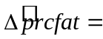 −.127 + … + .0068 wkends + .0125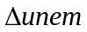
(.105) (.0072) (.0161)

− .0072 spdlaw + .0008 bltlaw
(.0238) (.0265)

n = 107, R² = .344,

where I have again suppressed the coefficients on the time trend and seasonal dummies. This regression basically shows that the change in prcfat cannot be explained by the change in unem or any of the policy variables. It does have some seasonality, which is why the R-squared is .344.

(iii) This is an example about how estimation in first differences loses the interesting implications of the model estimated in levels. Of course, this is not to say the levels regression is valid. But, as it turns out, we can reject a unit root in prcfat, and so we can at least justify using it in level form; see Computer Exercise 18.13. Generally, the issue of whether to take first differences is very difficult, even for professional time series econometricians.

C11.10 (i) Using the data through 2003 gives

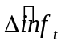 = 2.83 − .518 unem_{t}
(1.22) (.209)

n = 55, R² = .104

These estimates are similar to those obtained in equation (11.19), as we would hope. Both the intercept and slope have gotten a little smaller in magnitude.

(ii) The estimate of the natural rate is obtained as in Example 11.5. The new estimate is 2.83/.518 ≈ 5.46, which is slightly smaller than the 5.58 obtained using only the data through 1996.

(iii) The first order autocorrelation of unem is about .75. This is one of those tough cases: the correlation between unem_{t} and unem_{t-1} is large, but it is not especially close to one.

(iv) As when we use the data only through 1996, the model with 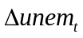 as the explanatory variable fits somewhat better (and yields a more pronounced tradeoff between inflation and unemployment):

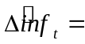 −.072 − .833
(.306) (.290)

n = 55, R² = .135

